**Information**

|  |  |  |
| --- | --- | --- |
| **CRIM ID** | **Title** | **Workstream** |
| C0034 | Custom Event to create MS Record | Forecasting (Supply Chain) |

**Revision History**

|  |  |  |  |
| --- | --- | --- | --- |
| **Revision** | **Date** | **By** | **Remarks** |
| 0.1 | 11/01/2021 | Jennifer Anderson | Base spec |
| 1.0 |  |  | Updates |
|  |  |  |  |
|  |  |  |  |

# CRIM Narrative

Tunstall requires a custom event that automatically creates an MS record for each site whenever a product is to be included in the sales forecast.

The planner will decide to

The automated steps should be as follows:

1. Add a new Master Schedule Level 1 Header

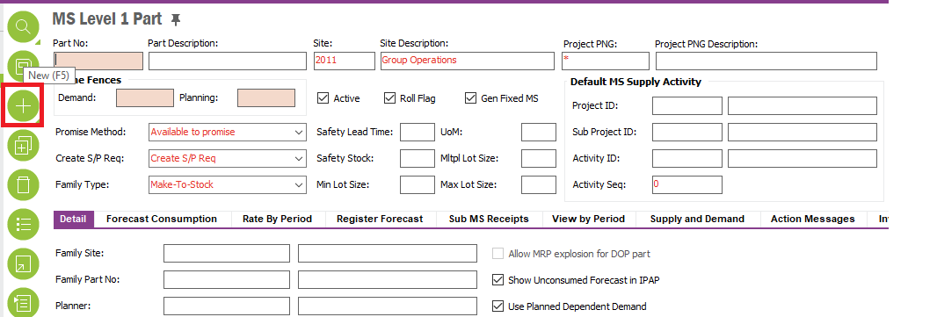

Pick up the selected inventory part number and enter XX for Demand and XX Planning timefences (check with Madeleine/Elaine).

1. Add a new MS Set in the Register Forecast tab

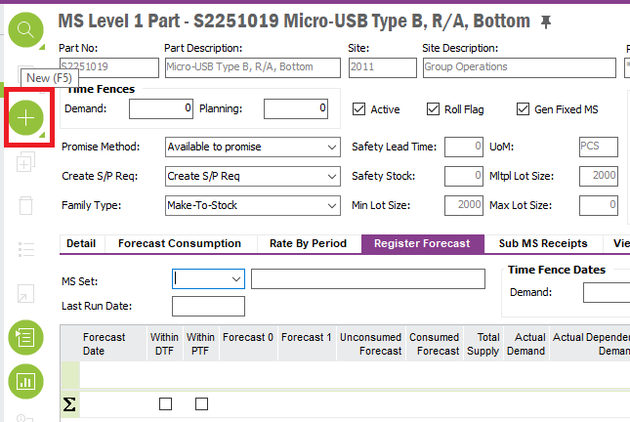

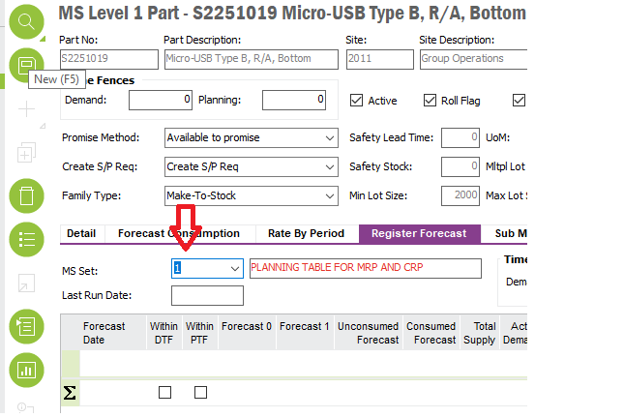

1. The custom event should replicate the Master Schedule out to all sites (2012, 2011 etc).

# Technical Proposal

*\*\*\*\* Guidance Notes – Remove prior to submission \*\*\*\**

# Technical Solution

## Technical Process

This implementation uses following custom objects;  
  
 **Custom Fields:**

MS Level 1 Part Window

Bulk Update - CF$_BULK_UPDATE

This check box will be set to true automatically when a user attempts to create a new record. Value

Of this field is used by the underlying logic when copying parts across sites.

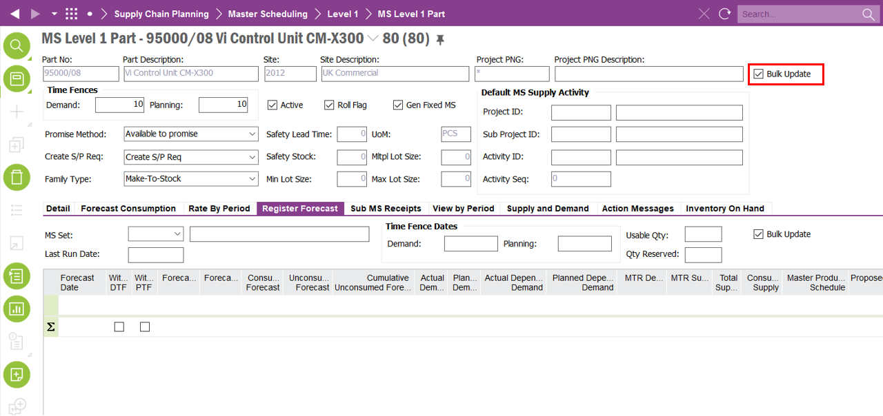

Bulk Update - CF$_BULK_UPDATE

This check box will be set to true automatically when a user attempts to create a new record. Value

Of this field is used by the underlying logic when copying parts across sites.

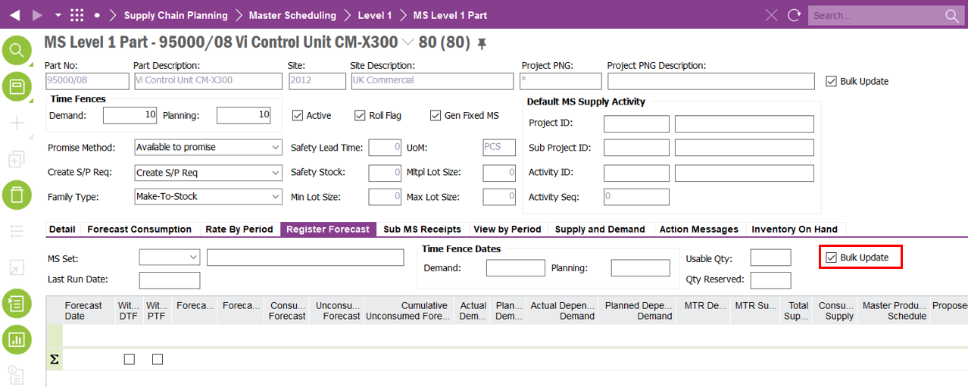

**Custom Events:**

DUPLICATE_MS_RECORD:

This Event duplicates "Ms Level 1 Part" record across sites excepts for site 2013

DUPLICATE_MS_SET”

This Event duplicates "Ms Level 1 Part" record across sites excepts for site 2013

***********************************************

## Report Components

********************************************

## Known Dependencies

*\*\*\*\* Guidance Notes – Remove prior to submission \*\*\*\**

***********************************************

# Deployment Instructions

*\*\*\*\* Guidance Notes – Remove prior to submission \*\*\*\**

***********************************************

# Developer Test Proposal

*\*\*\*\* Guidance Notes – Remove prior to submission \*\*\*\**

* *Tests recommended by the developer to be included in UAT*

*e.g.*

| **Test ID** | **Recommended Test** |
| --- | --- |
| 1 | Test the boundaries of all parameters |
| 2 |  |
| 3 |  |
| 4 |  |
| 5 |  |
| 6 |  |
| 7 |  |

***********************************************

# User Acceptance Tests

***********************************************